Trailing items without player scale attribute changed
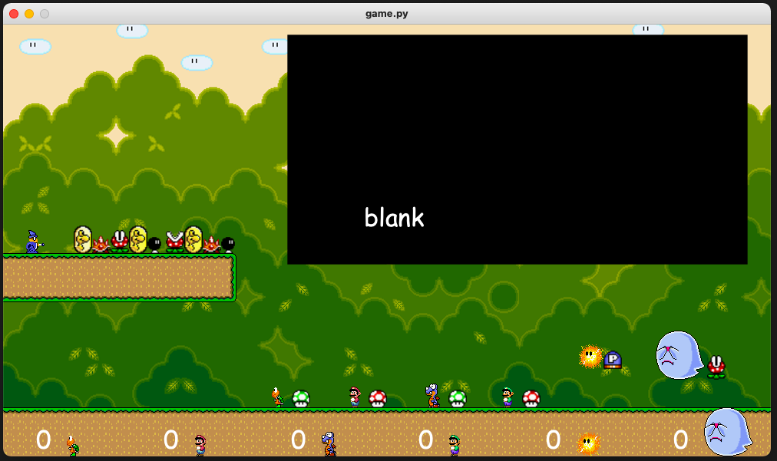
Trailing items with player scale attribute changed
